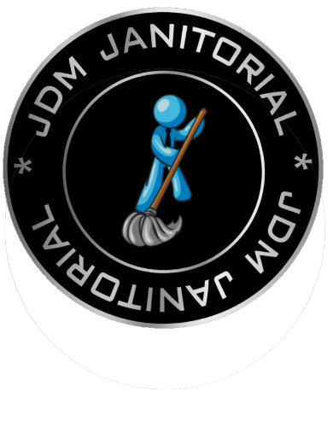
What Makes Facility Protection Disinfection Service Work?
Industry Leading Equipment, Information, and Implementation to Protect Your Team

Containing the spread of COVID-19 in offices, schools, manufacturing, distribution facilities, and other facilities is a daunting challenge. We have coupled JDM’s longstanding expertise in facility services with knowledge from the CDC and the guidance from other hygiene experts. We have created a program that is effective in limiting the surface-based spread of not only this virus, but all seasonal viruses, bacteria, fungus, and mildew, and bloodborne pathogens. EPA Approved Quaternary Disinfectants All products used in Facility Protection Disinfection Service meet EPA’s criteria for use against SARS-CoV-2, the virus that causes COVID-19. This means that these disinfectants have been proven to kill other human coronavirus types. This designation is the highest level of assurance that an anti-viral chemical is effective. If your janitorial is not disinfecting as well as cleaning, then your facility is not properly protected.
Electrostatic Sprayers These machines are designed to give the chemical an electrical charge that makes the chemical evenly spread over all grounded surfaces to kill infectious material in hard to reach places. It also ensures that the chemical stays on the surface long enough to kill viruses.
PPE (Personal Protective Equipment) Keeping your people safe while our people work is important to us. The well-being of both our teams and yours is critical, so every Facility Protection Disinfection Service team member is always equipped with the right PPE to get their job done safely.
Occupant Communication Signage Kits Even the best disinfection program only works if occupants do their part, too. Even the best disinfection program only works if occupants do their part with personal hygiene and social health practices. We can provide printed and digital signage to let people know disinfection is ongoing and to help promote social practices that keep everyone healthy together, like social distancing, handwashing, covering coughs and sneezes, and more.
Training and Certification All Facility Protection Disinfection Service team members, from our frontline workers all the way up to their supervisor’s supervisor, are thoroughly trained and tested. This includes eLearning, classroom sessions, videos, knowledge checks, and more. Our testing of both knowledge and the physical disinfection processes lets you feel confident that every team member completely understands their part.
Infectious Disease Control Technology When there is a new and better way to get the job done, we are going to evaluate it and incorporate it if it exceeds our current methods. Our Facility Protection Disinfection Service program will be continually updated not only to reflect current best practices, but we’re also committed to piloting new and emerging technology like UV disinfection.

